**Questions answers**

**Q .what is electricity?**

**Ans**. Electricity is the set of physical phenomena associated with the presence and motion of matter that has a property of electric charge. Electricity is related to magnetism, both being part of the phenomenon of electromagnetism Electricity is the presence and flow of electric charge. Using electricity we can transfer energy in ways that allow us to do simple chores. Its best-known form is the flow of electrons through conductors such as copper wires. The word "electricity" is sometimes used to mean "electrical energy".

**Q. What are the 4 types of electricity?**

1. Static Electricity.
2. Current Electricity.
3. Hydro Electricity.
4. Solar Electricity.

**Q. what is static electricity?**

**Ans**. Static Electricity is nothing but the contact between equal amount of protons and electrons (positively and negatively charged subatomic particles). In order to make this friction work the particles are supposed to be of opposite nature (+,-). If two same-kind particles i.e. positive-positive or negative-negative, it would then be called as a ‘Non-friction’.

**Q. what is current electricity?**

**Ans**. Current Electricity is a flow of electric charge across an electrical field. This current is lead through a conductor. The conductors are generally of two types, Good and Bad conductors. Good conductors are the ones which let the electric charge flow through them (Copper wires) and the bad conductors are the ones which resists the electric charge (Wood). The constant flow of electric charge causes the conductor to heat up very often.

**Q. what is hydro electricity .**

**Ans**. Hydro Electricity is generated by harnessing the power of moving water. It is manufactured in large power generating stations using the same basic principle of a small grist mill yet on a much larger and vastly improved scale for better efficiency. Electrical generators are attached to huge turbine devices which spin at great speeds as a result of water rushing through them.

**Q.what is solar electricity?**

**Ans**. Solar Electricity is generated with the only power that has been in existence since the living breathed on this planet, the huge and singular source named as Sun. The sun rays are the only source in Solar Electricity. It is generated with the help of Photovoltaic (PV) technology by converting solar energy into solar electricity from sunlight. PV Systems use sunlight to power ordinary electrical equipments for example: household appliances, computers & lightings.

**Q. what is current in electricity ?**

**Ans.** Electric current is the movement of electrons through a wire. Electric current is measured in amperes (amps) and refers to the number of charges that move through the wire per second.

**Q.why used electricity current?**

**Ans**. Electric currents create magnetic fields, which are used in motors, generators, inductors, and transformers. In ordinary conductors, they cause Joule heating, which creates light in incandescent light bulbs. Electric current is the flow of electrons through a complete circuit of conductors. It is used to power everything from our lights to our trains.

**Q.What is types of current in electricity ?**

**Ans**. There are two kinds of current electricity: direct current (DC) and alternating current (AC).

**Q. What is AC current ?**

**Ans.** Alternating current (AC) is an electric current which periodically reverses direction and changes its magnitude continuously with time in contrast to direct current (DC) which flows only in one direction.

**Q. why used AC current ?**

A. the voltage through transmission lines is very high, which reduces the current, which in turn minimizes the energy lost through transmission. This is why alternating current is preferred over direct current for transmitting electricity, as it is much cheaper to change the voltage of an alternating current.

**Q. what is properties of AC current ?**

**Ans**. Following are the properties of alternating current:

* Frequency is denoted by f and is defined as the number of cycles that either voltage or current has in one second. Hertz is the unit of frequency.
* Period is denoted by T and is defined as the interval of time needed for a signal to be repeated. Period is the inverse of frequency.

|  |
| --- |
| * \(T=frac{1}{f}\) |

* Peak-to-peak voltage is the difference between the maximum and minimum voltage.
* RMS voltage is the amount of AC power that is produced by heating which is equivalent to the DC power.
* Alternating current is produced in a generator.

**Q. where used AC current ?**

**Ans**. Alternating current, AC is generally used for power distribution, which is why the mains sockets in our homes and at work provide an alternating current to power whatever is needed, but direct current, DC is more widely used for the electronics boards themselves and for many other applications.

**Q. What is DC current ?**

**Ans**. Direct current (DC) is the one directional flow of electric charge. An electrochemical cell is a prime example of DC power. Direct current may flow through a conductor such as a wire, but can also flow through semiconductors, insulators, or even through a vacuum as in electron or ion beams. The electric current flows in a constant direction, distinguishing it from alternating current (AC). A term formerly used for this type of current was galvanic current.

**Q.** **why used DC current ?**

**Ans**. Direct current is used in any device that has a circuit board because the chips within these devices require a steady, unidirectional flow of electrons to operate and store data. Every home PC has a DC inverter built into the system, which then provides DC style power to the rest of the devices inside the case.

**Q. where used DC current ?**

**Ans**. Direct current has many uses, from the charging of batteries to large power supplies for electronic systems, motors, and more. Very large quantities of electrical energy provided via direct-current are used in smelting of aluminum and other electrochemical processes. Examples of DC electronics include:

* Cell phones.
* The LilyPad-based D&D Dice Gauntlet.
* Flat-screen TVs (AC goes into the TV, which is converted to DC)
* Flashlights.
* Hybrid and electric vehicles.

**Q. what is difference between AC and DC current ?**

**Ans.**

|  |  |
| --- | --- |
| Alternating Current | Direct Current |
| AC is safe to transfer longer distance even between two cities, and maintain the electric power. | DC cannot travel for a very long distance. It loses electric power. |
| The rotating magnets cause the change in direction of electric flow. | The steady magnetism makes DC flow in a single direction. |
| The frequency of AC is depended upon the country. But, generally, the frequency is 50 Hz or 60 Hz. | DC has no frequency of zero frequency. |
| In AC the flow of current changes its direction backwards periodically. | It flows in a single direction steadily. |
| Electrons in AC keep changing its directions – backward and forward | Electrons only move in one direction – that is forward. |

**Q. what is voltage in electricity?**

**Ans.** Voltage is the pressure from an electrical circuit's power source that pushes charged electrons (current) through a conducting loop, enabling them to do work such as illuminating a light. Voltage is an electrical potential difference, the difference in electric potential between two places. The unit for electrical potential difference, or voltage, is the volt.

**Q. what is types of voltage ?**

**Ans**. There are two types of voltage, DC voltage and AC voltage. The DC voltage (direct current voltage) always has the same polarity (positive or negative), such as in a battery. The AC voltage (alternating current voltage) alternates between positive and negative.

**Q. what is power ?**

**Ans**. In physics, power is the amount of energy transferred or converted per unit time. In the International System of Units, the unit of power is the watt, equal to one joule per second. In older works, power is sometimes called activity. Power is a scalar quantity. OR “We can define power as the rate of doing work, it is the work done in unit time. The SI unit of power is Watt (W) which is joules per second (J/s). Sometimes the power of motor vehicles and other machines is given in terms of Horsepower (hp), which is approximately equal to 745.7 watts.”

Power = Work / time

P = W / t

**Q. What is Average Power?**

**Ans**. We can define average power as the total energy consumed divided by the total time taken. In simple language, we can say that average power is the average amount of work done or energy converted per unit of time.

**Q. what is frequency ?**

**Ans.**Definition: The frequency is the number of oscillation per unit time. It is used for defining the cyclic process like rotation, oscillation, wave etc. The completion of the cyclic process at particular interval of time is known as the frequency. The SI unit of the frequency is Hertz. The symbol λ represents it. The one hertz means the wave completed one cycle in one second.

**Q. what is types of frequency ?**

**Ans**. Types of Frequency-:

The frequency is mainly classified into two categories.

1. Angular Frequency – The angular frequency shows the number of revolution at the fixed interval of time. The unit of angular frequency is Hertz. The relation between the frequency and angular frequency is expressed as;

[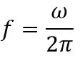](https://circuitglobe.com/wp-content/uploads/2018/04/frequency-equation.jpg)

Where, ω – angular frequency

2. Spatial Frequency – The frequency which depends on the spatial coordinate is known as the spatial frequency. It is inversely proportional to the wavelength. The spatial frequency measures the characteristic of the structure that is periodic in space.

**Q. what is analog signal?**

**Ans**. An analog signal is any continuous signal for which the time-varying feature of the signal is a representation of some other time-varying quantity, i.e., analogous to another time-varying signal.

**Q.what is Digital signal?**

**Ans**. A digital signal is a signal that is being used to represent data as a sequence of discrete values; at any given time it can only take on, at most, one of a finite number of values.

**Q. What is difference between analog signal and digital signal ?**

**Ans.**

|  |  |
| --- | --- |
| Analog Signals | Digital Signals |
| 1. Continuous signals | 1. Discrete signals |
| 1. Represented by sine waves | 1. Represented by square waves |
| 1. Human voice, natural sound, analog electronic devices are few examples | 1. Computers, optical drives, and other electronic devices |
| 1. Continuous range of values | 1. Discontinuous values |
| 1. Records sound waves as they are | 1. Converts into a binary waveform. |
| 1. Only be used in analog devices. | 1. Suited for digital electronics like computers, mobiles and more. |

**Q. what is ment by DATA ?**

**Ans**. Data as a general concept refers to the fact that some existing information or knowledge is represented or coded in some form suitable for better usage or processing. “Data is a collection of facts, such as numbers, words, measurements, observations or just descriptions of things.”

**Q.what is electronics ?**

**Ans**. Electronics comprises the physics, engineering, technology and applications that deal with the emission, flow and control of electrons in vacuum and matter.” Electronics is the study of how to control the flow of electrons. It deals with circuits that are made with parts called components and connecting wires that control the flow of electricity and direct it to do useful things.”

**Q.what is telecommunication ?**

**Ans**. Telecommunication is the transmission of information by various types of technologies over wire, radio, optical or other electromagnetic systems.

**Q. what is electric field ?**

**Ans**. An electric field is the physical field that surrounds each electric charge and exerts force on all other charges in the field, either attracting or repelling them. Electric fields originate from electric charges, or from time-varying magnetic fields.

* SI unit: volts per meter ([V/m](https://www.google.com/search?sxsrf=ALeKk03bklQD72Kb0Z4yQpmmzUpRvApWHA:1618111818984&q=V/m&stick=H4sIAAAAAAAAAONgVuLWT9c3NDLKSC5LylnEyhymnwsAqEqLdxUAAAA&sa=X&ved=2ahUKEwiqlrWhoPXvAhUJzjgGHZ85DUsQmxMoADAhegQITxAC))
* In SI base units: m⋅kg⋅s−3⋅A−1
* Derivations from other quantities: F / q
* Behaviour under coord transformation: vector

**Q. what is electric charge ?**

A. Electric charge is the physical property of matter that causes it to experience a force when placed in an electromagnetic field. There are two types of electric charge: positive and negative. Like charges repel each other and unlike charges attract each other.

* In SI base units: C = A⋅s
* SI unit: coulomb
* Other units: elementary charge; [faraday](https://www.google.com/search?sxsrf=ALeKk02bf-FJjK1l2R5bpdWXjC79i2M57Q:1618111971376&q=faraday&stick=H4sIAAAAAAAAAONgVuLQz9U3SDdIK1vEyp6WWJSYklgJAJwCPs8WAAAA&sa=X&ved=2ahUKEwi5vIrqoPXvAhXBxzgGHePZDHwQmxMoADAjegQIMxAC); ampere hour

**Q. what is magnetic field ?**

**Ans**. A magnetic field is a vector field that describes the magnetic influence on moving electric charges, electric currents, and magnetic materials. A moving charge in a magnetic field experiences a force perpendicular to its own velocity and to the magnetic field.

**Q.what is electronics signal?**

**Ans**. A message encoded by changing the voltage of an electric current is called an electronic signal. A signal is a function or a data set representing a physical quantity or variable. Usually, the signal encapsulates information about the behavior of a physical phenomenon, for example, electrical current flowing through a resistor, sonar sound waves propagating under water, or earthquakes.

**Q.what is quantum?**

**Ans.** In physics, a quantum (plural quanta) is the minimum amount of any physical entity (physical property) involved in an interaction. The fundamental notion that a physical property can be "quantized" is referred to as "the hypothesis of quantization".This means that the magnitude of the physical property can take on only discrete values consisting of integer multiples of one quantum.

**Q.what is photon?**

**Ans**. The photon (Greek: φῶς, phōs, light) is a type of elementary particle. It is the quantum of the electromagnetic field including electromagnetic radiation such as light and radio waves, and the force carrier for the electromagnetic force. Photons are massless, so they always move at the speed of light in vacuum, 299792458 m/s (or about 186,282 mi/s). The photon belongs to the class of bosons.

**Q. what is electromagnet ?**

**Ans**. An electromagnet is a type of magnet in which the magnetic field is produced by an electric current. Electromagnets usually consist of wire wound into a coil. A current through the wire creates a magnetic field which is concentrated in the hole, denoting the center of the coil.

**Q.what is electromagnetic signal ?**

**Ans**. Definition: Electromagnetic waves or EM waves are waves that are created as a result of vibrations between an electric field and a magnetic field. In other words, EM waves are composed of oscillating magnetic and electric fields.

**Q. what is radio wave ?**

**Ans**. Radio waves are a type of electromagnetic radiation with wavelengths in the electromagnetic spectrum longer than infrared light. Radio waves have frequencies as high as 300 gigahertz to as low as 30 hertz. At 300 GHz, the corresponding wavelength is 1 mm; at 30 Hz the corresponding wavelength is 10,000 km.

**Q. what is electromagnetic radiation ?**

**Ans**. In physics, electromagnetic radiation refers to the waves of the electromagnetic field, propagating through space, carrying electromagnetic radiant energy. It includes radio waves, microwaves, infrared, light, ultraviolet, X-rays, and gamma rays. All of these waves form part of the electromagnetic spectrum.

**Q.what is radio frequency?**

**Ans.** Radio frequency (RF) is the oscillation rate of an alternating electric current or voltage or of a magnetic, electric or electromagnetic field or mechanical system in the frequency range from around 20 kHz to around 300 GHz. This is roughly between the upper limit of audio frequencies and the lower limit of infrared frequencies; these are the frequencies at which energy from an oscillating current can radiate off a conductor into space as radio waves. Different sources specify different upper and lower bounds for the frequency range.

**Q. what is transmitter ?**

**Ans**. In [electronics](https://en.wikipedia.org/wiki/Electronics) and telecommunications a transmitter or radio transmitter is an [electronic device](https://en.wikipedia.org/wiki/Electronic_device) which produces [radio waves](https://en.wikipedia.org/wiki/Radio_wave) with an [antenna](https://en.wikipedia.org/wiki/Antenna_(radio)). The transmitter itself generates a [radio frequency](https://en.wikipedia.org/wiki/Radio_frequency) [alternating current](https://en.wikipedia.org/wiki/Alternating_current), which is applied to the [antenna](https://en.wikipedia.org/wiki/Antenna_(radio)). When excited by this alternating current, the antenna radiates radio waves. The term transmitter is usually limited to equipment that generates radio waves for [communication](https://en.wikipedia.org/wiki/Communication_engineering) purposes; or [radiolocation](https://en.wikipedia.org/wiki/Radiolocation), such as [radar](https://en.wikipedia.org/wiki/Radar) and navigational transmitters. Generators of radio waves for heating or industrial purposes, such as [microwave ovens](https://en.wikipedia.org/wiki/Microwave_oven) or [diathermy](https://en.wikipedia.org/wiki/Diathermy) equipment, are not usually called transmitters, even though they often have similar circuits.

**Q. what is application transmitter ?**

**Ans**. Transmitters are necessary component parts of all electronic devices that communicate by [radio](https://en.wikipedia.org/wiki/Radio_communication), such as [radio](https://en.wikipedia.org/wiki/Radio_broadcasting) and [television broadcasting](https://en.wikipedia.org/wiki/Television_broadcasting) stations, [cell phones](https://en.wikipedia.org/wiki/Cell_phone), [walkie-talkies](https://en.wikipedia.org/wiki/Walkie-talkie), [wireless computer networks](https://en.wikipedia.org/wiki/Wireless_LAN), [Bluetooth](https://en.wikipedia.org/wiki/Bluetooth) enabled devices, [garage door openers](https://en.wikipedia.org/wiki/Garage_door_opener), [two-way radios](https://en.wikipedia.org/wiki/Two-way_radio) in aircraft, ships, spacecraft, [radar](https://en.wikipedia.org/wiki/Radar) sets and navigational beacons.

**Q. what is receiver ?**

**Ans**. The receiver in [information theory](https://en.wikipedia.org/wiki/Information_theory) is the receiving end of a [communication channel](https://en.wikipedia.org/wiki/Communication_channel). It receives [decoded](https://en.wikipedia.org/wiki/Code) [messages](https://en.wikipedia.org/wiki/Message)/[information](https://en.wikipedia.org/wiki/Information) from the sender, who first [encoded](https://en.wikipedia.org/wiki/Code) them. Sometimes the receiver is modeled so as to include the decoder. Real-world receivers like [radio receivers](https://en.wikipedia.org/wiki/Receiver_(radio)) or [telephones](https://en.wikipedia.org/wiki/Telephone) can not be expected to receive as much information as predicted by the [noisy channel coding theorem](https://en.wikipedia.org/wiki/Noisy_channel_coding_theorem).

**Q.what is role of receiver ?**

**Ans**. The receiver's task is to interpret the sender's message, both verbal and nonverbal, with as little distortion as possible. The process of interpreting the message is known as decoding. ... The receiver prejudges the topic as too boring or difficult to understand and does not attempt to understand the message.

**Q. what is transmission medium ?**

**Ans**. The transmission medium can be defined as a pathway that can transmit information from a sender to a receiver. Transmission media are located below the physical layer and are controlled by the physical layer. Transmission media are also called communication channels.

**Q. what are type of transmission medium ?**

A. Transmission media are of two types –

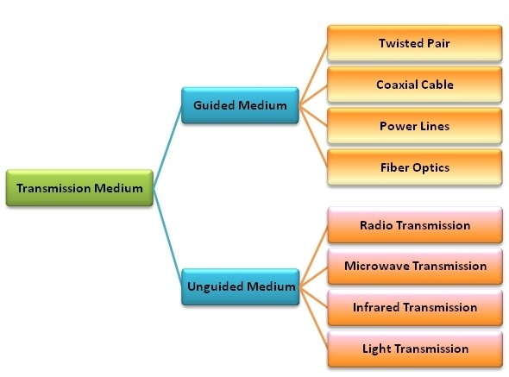

**Q. what is guided medium ?**

**Ans**. Guided transmission media are also called bounded media or wired media. They comprise cables or wires through which data is transmitted. They are called guided since they provide a physical conduit from the sender device to the receiver device. The signal traveling through these media are bounded by the physical limits of the medium.

The most popular guided media are −

* Twisted pair cable
* Coaxial cable
* Power lines
* Fiber optics

**Q. what is unguided medium ?**

**Ans**. Unguided transmission media are also called wireless media. They transport data in the form of electromagnetic waves that do not require any cables for transmission. These media are bounded by geographical boundaries. These type of communication is commonly referred to as wireless communications.

Unguided signals can travel in three ways −

* Ground propagation
* Sky propagation
* Line – of – sight propagation

**Q.what is communication system ?**

**Ans**. A communications system or communication system is a collection of individual [telecommunications networks](https://en.wikipedia.org/wiki/Telecommunications_network), [transmission](https://en.wikipedia.org/wiki/Transmission_(telecommunications)) systems, relay stations, tributary stations, and [terminal equipment](https://en.wikipedia.org/wiki/Terminal_equipment) usually capable of [interconnection](https://en.wikipedia.org/wiki/Interconnection) and [interoperation](https://en.wikipedia.org/wiki/Interoperation) to form an integrated whole. The components of a communications [system](https://en.wikipedia.org/wiki/System) serve a common purpose, are technically compatible, use common procedures, respond to controls, and operate in union.” The communication system is a system which describes the information exchange between two points. The process of transmission and reception of information is called communication. The major elements of communication are the Transmitter of information, Channel or medium of communication and the Receiver of information.”

**Q.What are the types of communication system ?**

**Ans.** Types Of Communication Systems

Depending on Signal specification or technology, the communication system is classified as follows:

(1) Analog:-

Analog technology communicates data as electronic signals of varying frequency or amplitude. Broadcast and telephone transmission are common examples of Analog technology.

(2) Digital:-

In digital technology, the data are generated and processed in two states: High (represented as 1) and Low (represented as 0). Digital technology stores and transmits data in the form of 1s and 0s.

Depending on the communication channel, the communication system is categorized as follows:

1. Wired (Line communication)

* Parallel wire communication
* Twisted wire communication
* Coaxial cable communication
* Optical fibre communication

2. Wireless (Space communication)

* Ground wave communication
* Skywave communication
* Space wave communication
* Satellite communication

**Q. what is difference between analog communication and digital communication ?**

**Ans.**

|  |  |  |
| --- | --- | --- |
| PARAMETERS | ANALOG COMMUNICATION | DIGITAL COMMUNICATION |
| Definiton | Analog Communication is the technology which uses Analog signal for the transmission of information. | Digital Communication is the technology which uses digital signal for the transmission of information. |
| Noise and Distortion | Get affected by Noise | Immune from Noise and Distortion |
| Error Probability | Error Probability is high due to parallax. | Error Probability is low |
| Hardware | Hardware is complicated and less flexible than digital system. | Hardware is flexible and less complicated than Analog system. |
| Cost | Low Cost | High Cost |
| Bandwidth Requirement | Low bandwidth requirement | High bandwidth Requirement |
| Power Requirement | High power is required | Low Power Requirement |
| Portability | Less Portable as the components are heavy | More portable due to compact equipments. |
| Modulation Used | Amplitude and Angle Modulation | Pulse coded Modulation or PCM, DPCM etc. |
| Representation of Signal | Analog signal can be represented by sine wave. | Digital signal is represented by square wave. |
| Signal Values | Consists of continuous values | Consists of discrete values |
| Example of Signal | Analog signal comprises of voice, sound etc. | Digital signals are used in computers |

**Q. What is information ?**

**Ans**. Message or information is the entity that is to be transmitted. It can be in the form of audio, video, temperature, picture, pressure, etc.

**Q. what is signal ?**

**Ans**. The single-valued function of time that carries the information. The information is converted into an electrical form for transmission.

**Q. what is transduser ?**

**Ans**. A device or an arrangement that converts one form of energy to the other. An electrical transducer converts physical variables such as pressure, force, temperature into corresponding electrical signal variations. Example: Microphone – converts audio signals into electrical signals. Photodetector – converts light signals into electrical signals.

**Q. what is amplifire ?.**

**Ans**. The electronic circuit or device that increases the amplitude or the strength of the transmitted signal is called an amplifier. When the signal strength becomes less than the required value, amplification can be done anywhere in between transmitter and receiver. A DC power source will provide for the amplification.

**Q. what is modulator ?**

**Ans**. As the original message signal cannot be transmitted over a large distance because of their low frequency and amplitude, they are superimposed with high frequency and amplitude wave called carrier wave. This phenomenon of superimposing of message signal with a carrier wave is called modulation. And the resultant wave is a modulated wave which is to be transmitted.

**Q. what are types of modulation ?**

**Ans.**

i. Amplitude Modulation (AM)

The process of changing the amplitude of the signal wave by impressing or superimposing it on a high-frequency carrier wave, keeping its frequency constant is called amplitude modulation.

ii. Frequency Modulation (FM)

Frequency modulation is a technique in which the frequency of the message signal is varied by modulating with a carrier wave. It is better than deficient than amplitude modulation because it eliminates noise from various sources.

iii. Phase Modulation (PM)

The phase of the carrier wave changes the phase of the signal wave. The phase shift after modulation is dependent on the frequency of the carrier wave as well. Phase modulated waves are immune to noise to a greater extent.

**Q what is Antenna?**

**Ans.** An Antenna is a structure or a device that is radiate and receive electromagnetic waves. So, they are used in both transmitters and receivers. An antenna is basically a metallic object, often a collection of wires. The electromagnetic waves are polarised according to the position of the antenna.

**Q. what is channel ?**

**Ans**. A channel refers to a physical medium such as wire, cables, space through which the signal is passed from transmitter to the receiver. There are many channel impairments that affect the channel performance to a pronounced level. Noise, Attenuation and distortion to mention the major impairments.

**Q. what is noise ?**

**Ans**. Noise is one of the channel imperfection or impairment in the received signal at the destination. There are external and internal sources that cause noise. External sources include interference, i.e. interference from nearby transmitted signals (cross talk), interference generated by natural source such as lightning, solar or cosmic radiation, from automobile generated radiation, etc. The external noise can be minimised and eliminated by appropriate design of the channel, shielding of cables. Also by digital transmission external noise can be much minimised.

**Q.what is Attenuation ?**

**Ans**. Attenuation is a problem caused by the medium. When the signal is propagating for a longer distance through a medium, depending on the length of the medium the initial power decreases. The loss in initial power is directly proportional to the length of the medium. Using amplifiers, the signal power is strengthened or amplified so as to reduce attenuation. Also, digital signals are comparatively less prone to attenuation than analogue signals.

**Q. what is distortion ?**

**Ans**. It is also another type of channel problem. When the signal is distorted, the distorted signal may have frequency and bandwidth different from the transmitted signal. The variation in the signal frequency can be linear or non-linear.

**Q. what is demodulator?**

**Ans**. It is the inverse phenomenon of modulation. The process of separation of message signal from the carrier wave takes place in the demodulator. The information is retrieved from the modulated wave.

**Q. what is repeaters ?**

**Ans**. Repeaters are placed at different locations in between the transmitter and receiver. A repeater receives the transmitted signal, amplifies it and send it to the next repeater without distorting the original signal.

**Q. what is network ?**

**Ans**. A network consists of two or more computers that are linked in order to share resources (such as printers and CDs), exchange files, or allow electronic communications. The computers on a network may be linked through cables, telephone lines, radio waves, satellites, or infrared light beams.

**Q. what is computer network ?**

**Ans**. A computer network is a group of computers linked to each other that enables the computer to communicate with another computer and share their resources, data, and applications.

**Q. what is types of computer network ?**

**Ans**. A computer network can be categorized by their size. A computer network is mainly of four types:

* LAN(Local Area Network)
* PAN(Personal Area Network)
* MAN(Metropolitan Area Network)
* WAN(Wide Area Network)

**Q. what is charateratics of LAN ?**

1. Local Area Network is a group of computers connected to each other in a small area such as building, office.
2. LAN is used for connecting two or more personal computers through a communication medium such as twisted pair, coaxial cable, etc.
3. It is less costly as it is built with inexpensive hardware such as hubs, network adapters, and ethernet cables.
4. The data is transferred at an extremely faster rate in Local Area Network.
5. Local Area Network provides higher security.

**Q. what is charateratics of PAN ?**

1. Personal Area Network is a network arranged within an individual person, typically within a range of 10 meters.
2. Personal Area Network is used for connecting the computer devices of personal use is known as Personal Area Network.
3. Thomas Zimmerman was the first research scientist to bring the idea of the Personal Area Network.
4. Personal Area Network covers an area of 30 feet.
5. Personal computer devices that are used to develop the personal area network are the laptop, mobile phones, media player and play stations.

**Q. what is types of LAN ?**

**Ans**. 1. Wireless Personal Area Network:- Wireless Personal Area Network is developed by simply using wireless technologies such as WiFi, Bluetooth. It is a low range network.

2. Wired Personal Area Network:- Wired Personal Area Network is created by using the USB.

**Q. what is charateratics of MAN ?**

1. A metropolitan area network is a network that covers a larger geographic area by interconnecting a different LAN to form a larger network.
2. Government agencies use MAN to connect to the citizens and private industries.
3. In MAN, various LANs are connected to each other through a telephone exchange line.
4. The most widely used protocols in MAN are RS-232, Frame Relay, ATM, ISDN, OC-3, ADSL, etc.
5. It has a higher range than Local Area Network(LAN).

**Q. what is application of MAN ?**

* MAN is used in communication between the banks in a city.
* It can be used in an Airline Reservation.
* It can be used in a college within a city.
* It can also be used for communication in the military.

**Q. what is WAN ?**

1. A Wide Area Network is a network that extends over a large geographical area such as states or countries.
2. A Wide Area Network is quite bigger network than the LAN.
3. A Wide Area Network is not limited to a single location, but it spans over a large geographical area through a telephone line, fibre optic cable or satellite links.
4. The internet is one of the biggest WAN in the world.
5. A Wide Area Network is widely used in the field of Business, government, and education.

**Q. what is advantages of WAN?**

* Geographical area: A Wide Area Network provides a large geographical area. Suppose if the branch of our office is in a different city then we can connect with them through WAN. The internet provides a leased line through which we can connect with another branch.
* Centralized data: In case of WAN network, data is centralized. Therefore, we do not need to buy the emails, files or back up servers.
* Get updated files: Software companies work on the live server. Therefore, the programmers get the updated files within seconds.
* Exchange messages: In a WAN network, messages are transmitted fast. The web application like Facebook, Whatsapp, Skype allows you to communicate with friends.
* Sharing of software and resources: In WAN network, we can share the software and other resources like a hard drive, RAM.
* Global business: We can do the business over the internet globally.
* High bandwidth: If we use the leased lines for our company then this gives the high bandwidth. The high bandwidth increases the data transfer rate which in turn increases the productivity of our company.

**Q.what is disadvantages of WAN ?**

* Security issue: A WAN network has more security issues as compared to LAN and MAN network as all the technologies are combined together that creates the security problem.
* Needs Firewall & antivirus software: The data is transferred on the internet which can be changed or hacked by the hackers, so the firewall needs to be used. Some people can inject the virus in our system so antivirus is needed to protect from such a virus.
* High Setup cost: An installation cost of the WAN network is high as it involves the purchasing of routers, switches.
* Troubleshooting problems: It covers a large area so fixing the problem is difficult.

**Q. what is internet network ?**

**Ans.** An internetwork is defined as two or more computer network LANs or WAN or computer network segments are connected using devices, and they are configured by a local addressing scheme. This process is known as internetworking.

* An interconnection between public, private, commercial, industrial, or government computer networks can also be defined as internetworking.
* An internetworking uses the internet protocol.
* The reference model used for internetworking is Open System Interconnection(OSI).

**Q. what types of internet network ?**

**Ans**. 1. Extranet: An extranet is a communication network based on the internet protocol such as Transmission Control protocol and internet protocol. It is used for information sharing. The access to the extranet is restricted to only those users who have login credentials. An extranet is the lowest level of internetworking. It can be categorized as MAN, WAN or other computer networks. An extranet cannot have a single LAN, atleast it must have one connection to the external network.

2. Intranet: An intranet is a private network based on the internet protocol such as Transmission Control protocol and internet protocol. An intranet belongs to an organization which is only accessible by the organization's employee or members. The main aim of the intranet is to share the information and resources among the organization employees. An intranet provides the facility to work in groups and for teleconferences.

**Q. what is advantages of internet network ?**

* Communication: It provides a cheap and easy communication. An employee of the organization can communicate with another employee through email, chat.
* Time-saving: Information on the intranet is shared in real time, so it is time-saving.
* Collaboration: Collaboration is one of the most important advantage of the intranet. The information is distributed among the employees of the organization and can only be accessed by the authorized user.
* Platform independency: It is a neutral architecture as the computer can be connected to another device with different architecture.
* Cost effective: People can see the data and documents by using the browser and distributes the duplicate copies over the intranet. This leads to a reduction in the cost.

**Q. what is tepology?**

**Ans**. Geometric representation of how the computers are connected to each other is known as topology. There are five types of topology – Mesh, Star, Bus, Ring and Hybrid.

**Q.what is mesh topology?**

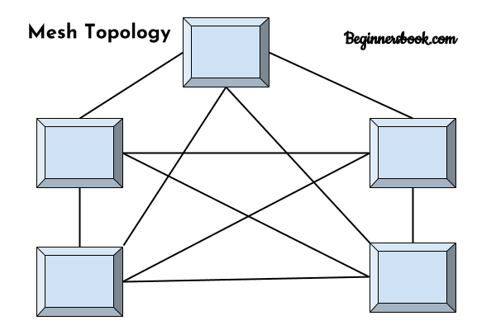  
In mesh topology each device is connected to every other device on the network through a dedicated point-to-point link. When we say dedicated it means that the link only carries data for the two connected devices only. Lets say we have n devices in the network then each device must be connected with (n-1) devices of the network. Number of links in a mesh topology of n devices would be n(n-1)/2.

**Q. what is advantages of mesh topology?**

**Ans**. 1. No data traffic issues as there is a dedicated link between two devices which means the link is only available for those two devices.  
2. Mesh topology is reliable and robust as failure of one link doesn’t affect other links and the communication between other devices on the network.  
3. Mesh topology is secure because there is a point to point link thus unauthorized access is not possible.  
4. Fault detection is easy.

**Q. what is disadvantages of mesh topology?**

**Ans**. 1. Amount of wires required to connected each system is tedious and headache.  
2. Since each device needs to be connected with other devices, number of I/O ports required must be huge.  
3. Scalability issues because a device cannot be connected with large number of devices with a dedicated point to point link.

**Q.what is star topology?**

**Ans**.

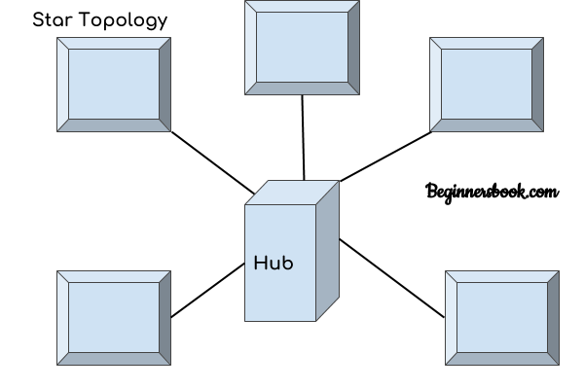  
In star topology each device in the network is connected to a central device called hub. Unlike Mesh topology, star topology doesn’t allow direct communication between devices, a device must have to communicate through hub. If one device wants to send data to other device, it has to first send the data to hub and then the hub transmit that data to the designated device.

**Q. what is advantages of star topology?**

**Ans**. 1. Less expensive because each device only need one I/O port and needs to be connected with hub with one link.  
2. Easier to install  
3. Less amount of cables required because each device needs to be connected with the hub only.  
4. Robust, if one link fails, other links will work just fine.  
5. Easy fault detection because the link can be easily identified.

**Q.what is disadvatages of star topology?**

**Ans**. 1. If hub goes down everything goes down, none of the devices can work without hub.  
2. Hub requires more resources and regular maintenance because it is the central system of star topology.

**Q.what is bus topology?**

**Ans**.

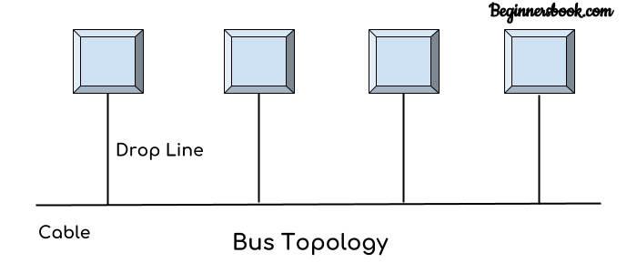  
In bus topology there is a main cable and all the devices are connected to this main cable through drop lines. There is a device called tap that connects the drop line to the main cable. Since all the data is transmitted over the main cable, there is a limit of drop lines and the distance a main cable can have.

**Q. what is advantages and disadvantages of bus topology ?**

**Ans**. Advantages of bus topology

1. Easy installation, each cable needs to be connected with backbone cable.  
2. Less cables required than Mesh and star topology

Disadvantages of bus topology

1. Difficultly in fault detection.  
2. Not scalable as there is a limit of how many nodes you can connect with backbone cable.

Q what is ring topology ?

**Ans**.

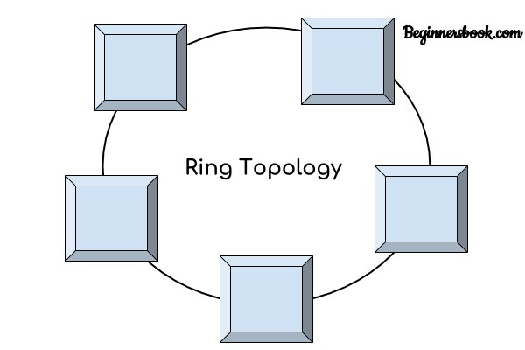  
In ring topology each device is connected with the two devices on either side of it. There are two dedicated point to point links a device has with the devices on the either side of it. This structure forms a ring thus it is known as ring topology. If a device wants to send data to another device then it sends the data in one direction, each device in ring topology has a repeater, if the received data is intended for other device then repeater forwards this data until the intended device receives it.

**Q. what is advantages and disadvantages of ring tepology ?**

A. Advantages of Ring Topology

1. Easy to install.  
2. Managing is easier as to add or remove a device from the topology only two links are required to be changed.

Disadvantages of Ring Topology

1. A link failure can fail the entire network as the signal will not travel forward due to failure.  
2. Data traffic issues, since all the data is circulating in a ring.

**Q.what is hybrid tepology ?**

**Ans**.

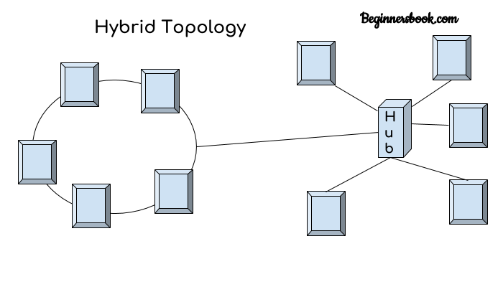  
A combination of two or more topology is known as hybrid topology. For example a combination of star and mesh topology is known as hybrid topology.

**Q. what is advantages and disadvantages of hybrid tepology ?**

**Ans**. Advantages of Hybrid topology

1. We can choose the topology based on the requirement for example, scalability is our concern then we can use star topology instead of bus technology.  
2. Scalable as we can further connect other computer networks with the existing networks with different topologies.

Disadvantages of Hybrid topology

1. Fault detection is difficult.  
2. Installation is difficult.  
3. Design is complex so maintenance is high thus expensive.

**Q. What is router ?**

**Ans**. Router: Router joins multiple computer networks to each other. For example lets say a company runs 100 computers over a local area network(LAN) and another company runs another LAN of 150 computers. These both LANs can be connected with each other through a internet connection which is provided by the router.

**Q. what is hub ?**

**Ans**. Hub: Hub acts as a device that connects all the computer in a network to each other. Any request that comes from a client computer first received by Hub and then hub transmit this request over a network so that the correct server receives and respond to it.

**Q What is Multiplexing?**

**Ans** Multiplexing is a technique used to combine and send the multiple data streams over a single medium. The process of combining the data streams is known as multiplexing and hardware used for multiplexing is known as a multiplexer. Multiplexing is achieved by using a device called Multiplexer (MUX) that combines n input lines to generate a single output line. Multiplexing follows many-to-one, i.e., n input lines and one output line. Demultiplexing is achieved by using a device called Demultiplexer (DEMUX) available at the receiving end. DEMUX separates a signal into its component signals (one input and n outputs). Therefore, we can say that demultiplexing follows the one-to-many approach.

**Q. Why Multiplexing?**

**Ans** The transmission medium is used to send the signal from sender to receiver. The medium can only have one signal at a time.

If there are multiple signals to share one medium, then the medium must be divided in such a way that each signal is given some portion of the available bandwidth. For example: If there are 10 signals and bandwidth of medium is100 units, then the 10 unit is shared by each signal. When multiple signals share the common medium, there is a possibility of collision. Multiplexing concept is used to avoid such collision. Transmission services are very expensive.

**Q. what is Concept of Multiplexing**

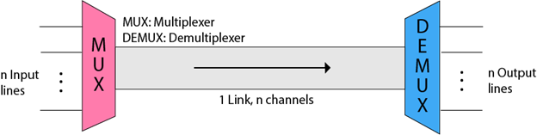

The 'n' input lines are transmitted through a multiplexer and multiplexer combines the signals to form a composite signal.

The composite signal is passed through a Demultiplexer and demultiplexer separates a signal to component signals and transfers them to their respective destinations.

**Q. what is Advantages of Multiplexing:**

* More than one signal can be sent over a single medium.
* The bandwidth of a medium can be utilized effectively.

**Q. what is types of Multiplexing Techniques**

**Ans** Multiplexing techniques can be classified as:

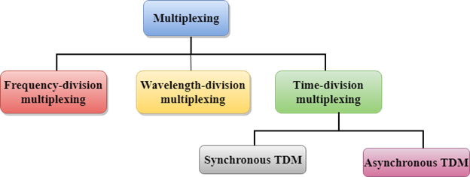

**Q. what is Frequency-division Multiplexing (FDM)**

* It is an analog technique.
* Frequency Division Multiplexing is a technique in which the available bandwidth of a single transmission medium is subdivided into several channels.

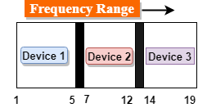

* In the above diagram, a single transmission medium is subdivided into several frequency channels, and each frequency channel is given to different devices. Device 1 has a frequency channel of range from 1 to 5.
* The input signals are translated into frequency bands by using modulation techniques, and they are combined by a multiplexer to form a composite signal.
* The main aim of the FDM is to subdivide the available bandwidth into different frequency channels and allocate them to different devices.
* Using the modulation technique, the input signals are transmitted into frequency bands and then combined to form a composite signal.
* The carriers which are used for modulating the signals are known as sub-carriers. They are represented as f1,f2..fn.
* FDM is mainly used in radio broadcasts and TV networks.

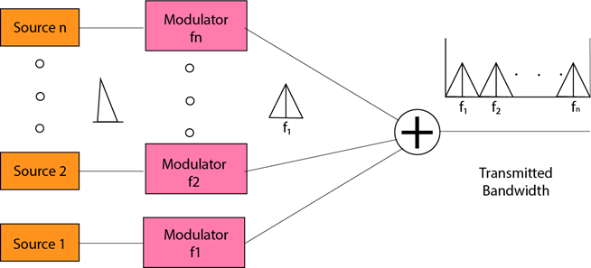

**Q. what is Advantages Of FDM:**

* FDM is used for analog signals.
* FDM process is very simple and easy modulation.
* A Large number of signals can be sent through an FDM simultaneously.
* It does not require any synchronization between sender and receiver.

**Q. what is Disadvantages Of FDM:**

* FDM technique is used only when low-speed channels are required.
* It suffers the problem of crosstalk.
* A Large number of modulators are required.
* It requires a high bandwidth channel.

**Q. what is Applications Of FDM:**

* FDM is commonly used in TV networks.
* It is used in FM and AM broadcasting. Each FM radio station has different frequencies, and they are multiplexed to form a composite signal. The multiplexed signal is transmitted in the air.

**Q. what is Wavelength Division Multiplexing (WDM)**

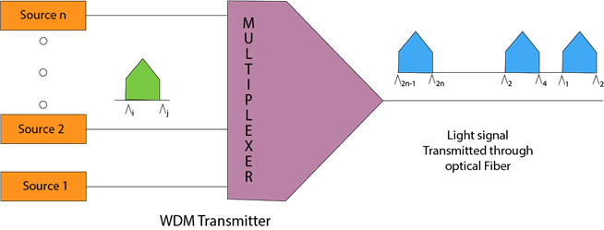

* Wavelength Division Multiplexing is same as FDM except that the optical signals are transmitted through the fibre optic cable.
* WDM is used on fibre optics to increase the capacity of a single fibre.
* It is used to utilize the high data rate capability of fibre optic cable.
* It is an analog multiplexing technique.
* Optical signals from different source are combined to form a wider band of light with the help of multiplexer.
* At the receiving end, demultiplexer separates the signals to transmit them to their respective destinations.
* Multiplexing and Demultiplexing can be achieved by using a prism.
* Prism can perform a role of multiplexer by combining the various optical signals to form a composite signal, and the composite signal is transmitted through a fibre optical cable.
* Prism also performs a reverse operation, i.e., demultiplexing the signal.

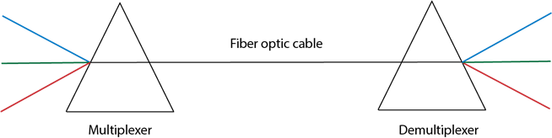

**Q. what is Time Division Multiplexing**

* It is a digital technique.
* In Frequency Division Multiplexing Technique, all signals operate at the same time with different frequency, but in case of Time Division Multiplexing technique, all signals operate at the same frequency with different time.
* In Time Division Multiplexing technique, the total time available in the channel is distributed among different users. Therefore, each user is allocated with different time interval known as a Time slot at which data is to be transmitted by the sender.
* A user takes control of the channel for a fixed amount of time.
* In Time Division Multiplexing technique, data is not transmitted simultaneously rather the data is transmitted one-by-one.
* In TDM, the signal is transmitted in the form of frames. Frames contain a cycle of time slots in which each frame contains one or more slots dedicated to each user.
* It can be used to multiplex both digital and analog signals but mainly used to multiplex digital signals.

**Q. what is types of TDM ?**

**Ans**. There are two types of TDM:

* Synchronous TDM
* Asynchronous TDM

**Q . What is Synchronous TDM**

* A Synchronous TDM is a technique in which time slot is preassigned to every device.
* In Synchronous TDM, each device is given some time slot irrespective of the fact that the device contains the data or not.
* If the device does not have any data, then the slot will remain empty.
* In Synchronous TDM, signals are sent in the form of frames. Time slots are organized in the form of frames. If a device does not have data for a particular time slot, then the empty slot will be transmitted.
* The most popular Synchronous TDM are T-1 multiplexing, ISDN multiplexing, and SONET multiplexing.
* If there are n devices, then there are n slots.

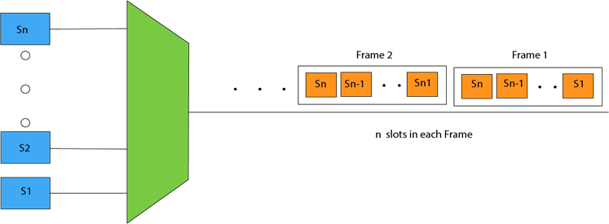

Concept Of Synchronous TDM

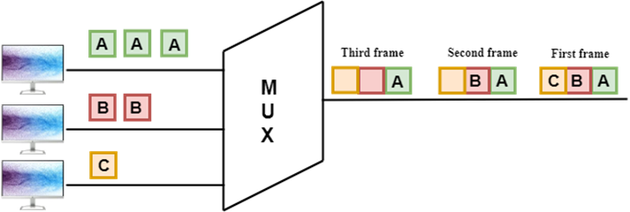

In the above figure, the Synchronous TDM technique is implemented. Each device is allocated with some time slot. The time slots are transmitted irrespective of whether the sender has data to send or not.

**Q. what is Disadvantages Of Synchronous TDM:**

**Ans** The capacity of the channel is not fully utilized as the empty slots are also transmitted which is having no data. In the above figure, the first frame is completely filled, but in the last two frames, some slots are empty. Therefore, we can say that the capacity of the channel is not utilized efficiently.

The speed of the transmission medium should be greater than the total speed of the input lines. An alternative approach to the Synchronous TDM is Asynchronous Time Division Multiplexing.

**Q. what is Asynchronous TDM**

* An asynchronous TDM is also known as Statistical TDM.
* An asynchronous TDM is a technique in which time slots are not fixed as in the case of Synchronous TDM. Time slots are allocated to only those devices which have the data to send. Therefore, we can say that Asynchronous Time Division multiplexor transmits only the data from active workstations.
* An asynchronous TDM technique dynamically allocates the time slots to the devices.
* In Asynchronous TDM, total speed of the input lines can be greater than the capacity of the channel.
* Asynchronous Time Division multiplexor accepts the incoming data streams and creates a frame that contains only data with no empty slots.
* In Asynchronous TDM, each slot contains an address part that identifies the source of the data.

Multiplexing Techniques

* The difference between Asynchronous TDM and Synchronous TDM is that many slots in Synchronous TDM are unutilized, but in Asynchronous TDM, slots are fully utilized. This leads to the smaller transmission time and efficient utilization of the capacity of the channel.
* In Synchronous TDM, if there are n sending devices, then there are n time slots. In Asynchronous TDM, if there are n sending devices, then there are m time slots where m is less than n (m<n).
* The number of slots in a frame depends on the statistical analysis of the number of input lines.

Concept Of Asynchronous TDM

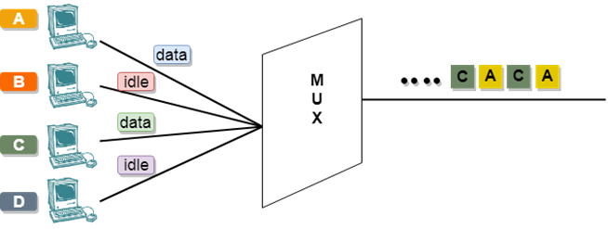

In the above diagram, there are 4 devices, but only two devices are sending the data, i.e., A and C. Therefore, the data of A and C are only transmitted through the transmission line.

**Q what is Switching**

* When a user accesses the internet or another computer network outside their immediate location, messages are sent through the network of transmission media. This technique of transferring the information from one computer network to another network is known as switching.
* Switching in a computer network is achieved by using switches. A switch is a small hardware device which is used to join multiple computers together with one local area network (LAN).
* Network switches operate at layer 2 (Data link layer) in the OSI model.
* Switching is transparent to the user and does not require any configuration in the home network.
* Switches are used to forward the packets based on MAC addresses.
* A Switch is used to transfer the data only to the device that has been addressed. It verifies the destination address to route the packet appropriately.
* It is operated in full duplex mode.
* Packet collision is minimum as it directly communicates between source and destination.
* It does not broadcast the message as it works with limited bandwidth.

**Q. Why is Switching Concept required?**

* Switching concept is developed because of the following reasons:
* Bandwidth: It is defined as the maximum transfer rate of a cable. It is a very critical and expensive resource. Therefore, switching techniques are used for the effective utilization of the bandwidth of a network.
* Collision: Collision is the effect that occurs when more than one device transmits the message over the same physical media, and they collide with each other. To overcome this problem, switching technology is implemented so that packets do not collide with each other.

**Q. what is Advantages of Switching**?

* Switch increases the bandwidth of the network.
* It reduces the workload on individual PCs as it sends the information to only that device which has been addressed.
* It increases the overall performance of the network by reducing the traffic on the network.
* There will be less frame collision as switch creates the collision domain for each connection.

**Q. what is Disadvantages of Switching:**

* A Switch is more expensive than network bridges.
* A Switch cannot determine the network connectivity issues easily.
* Proper designing and configuration of the switch are required to handle multicast packets.

**Q. what is handshaking** ?

In telecommunications, a handshake is an automated process of negotiation between two participants through the exchange of information that establishes the protocols of a communication link at the start of the communication, before full communication begins.

**Q. What is handshaking signals in microprocessor?**

The microprocessor and different I/O devices operate at different speeds. For this reason, signals are exchanged between The first responding MPU and slow responding I/O devices prior to data transfer. These signals are called handshake signals.

**Q. what is hardware handshaking and software handshaiking ?**

**Ans** A "hardware handshake" uses dedicated wires such as the request-to-send (RTS) and clear-to-send (CTS) lines in an RS-232 serial transmission. A "software handshake" sends codes such as "synchronize" (SYN) and "acknowledge" (ACK) in a TCP/IP transmission. See [RTS](https://www.pcmag.com/encyclopedia/term/rts), [CTS](https://www.pcmag.com/encyclopedia/term/cts) and [RS-232](https://www.pcmag.com/encyclopedia/term/rs-232).

**Q. what is computer hardware ?**

**Ans**. computer hardware includes the physical parts of a computer, such as the case, central processing unit, monitor, mouse, keyboard, computer data storage, graphics card, sound card, speakers and motherboard. By contrast, software is the set of instructions that can be stored and run by hardware.

**Q. what is computer software ?**

**Ans.** Software is a collection of instructions and data that tell a computer how to work. This is in contrast to physical hardware, from which the system is built and actually performs the work.

**Q . what is difference between computer Hardware and software ?**

|  |  |  |
| --- | --- | --- |
| Parameters | Hardware | software |
| Definition | Devices that are required to store and execute (or run) the software. | Collection of instructions that enables a user to interact with the computer. Software is a program that enables a computer to perform a specific task, as opposed to the physical components of the system (hardware). | |
| Types | Input, storage, processing, control, and output devices. | System software, Programming software, and Application software. | |
| Function | Hardware serve as the delivery system for software solutions. The hardware of a computer is infrequently changed, in comparison with software and data, which are “soft” in the sense that they are readily created, modified, or erased on the comput | To perform the specific task you need to complete. Software is generally not needed to for the hardware to perform its basic level tasks such as turning on and reponding to input. | |
| Examples | CD-ROM, monitor, printer, video card, scanners , label makers, [routers and modems](https://www.diffen.com/difference/Modem_vs_Router). | QuickBooks, Adobe Acrobat, Google Chrome, Microsoft Word, Microsoft Excel, Apple Maps | |
| Inter dependency | Hardware starts functioning once software is loaded. | To deliver its set of instructions, Software is installed on hardware. | |
| Failure | Hardware failure is random. Hardware does have increasing failure at the last stage. | Software failure is systematic. Software does not have an increasing failure rate. | |
| Durability | Hardware wears out over time. | Software does not wear out over time. However, bugs are discovered in software as time passes. | |
| Nature | Hardware is physical in nature. | Software is logical in nature. | |

**Q. What are Communication Protocols & Their Working**

**Ans** In the digital world, communication protocols create many rules. For instance, on the Internet, the formation of these protocols can be done by groups such as the association of WWW (World Wide Web) or W3C & the IETF (Internet Engineering Task) assists in providing worldwide operations & limits different types of liability as well as vulnerabilities within these technologies. Communication protocol plays a key role when HTTP turns into HTTPS otherwise an extensive use of SSL (Secure Sockets Layer) certificate becomes the standard. Other types of protocols use the data packets within global network routes and sometimes its looks like particle physics. So, technology is advancing day by day, so different communication protocols are used in advanced networks. The [Internet of Things (IoT)](https://www.elprocus.com/future-technology-internet-of-things/) assures the latest developing communications protocols to connect the wide set of devices to a universal network. This article discusses an overview of communication protocols in embedded systems.

**Q. What are Communication Protocols?**

**Ans** The proper descriptions of digital message formats as well as rules are known communication protocols. The main function of these protocols is to exchange messages from one computer system to another. These are significant in telecommunications systems as they consistently send and receive messages. These protocols cover error detection & correction, signaling, and authentication. They can also explain the semantics, syntax & brings analog & digital communications together.

**Q. Why is Communication Protocol Important?**

**Ans** Communication protocols assist varied network devices to converse with each other by transmitting the analog signals, digital signals, different files & process the data from one device to other devices. These types of protocols are applicable in telecommunication & computer networks where suitable rules are executed to transmit information from source to destination. The most vital protocols within networking are TCP (Transmission Control Protocol) & User datagram protocol (UDP).

**Q. what is Types of Communication Protocols ?**

**Ans** There are two types of communication protocols which are classified below:

* Inter System Protocol
* Intra System Protocol

**Q. what is Inter System Protocol ?**

**Ans** The inter-system protocol using to communicate the two different devices. Like communication between computer to microcontroller kit. The communication is done through an inter bus system.

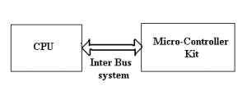Inter Bus System Protocols

The different categories of intersystem protocol mainly include the following.

* UART Protocol
* USART Protocol
* USB Protocol

**Q. What is UART Protocol ?**

UART stands for a universal asynchronous transmitter and receiver. UART Protocols is a serial communication with two wired protocols. The data cable signal lines are labeled as Rx and Tx. Serial communication is commonly used for transmitting and receiving the signal. It is transferred and receives the data serially bit by bit without class pulses. The UART takes bytes of data and sends the individual bits in a sequential manner. UART is a half-duplex protocol. Half-duplex means transferring and receiving the data but not at the same time. Most of the controllers have hardware UART on board. It uses a single data line for transmitting and receiving the data. It has one start bit, 8-bit data and a one-stop bit mean the 8-bit data transfer one’s signal is high to low.

Ex: Emails, SMS, Walkie-talkie.

**Q. what is USART Protocol ?**

**Ans** USART stands for a universal synchronous and asynchronous transmitter and receiver. It is a serial communication of a two-wire protocol. The data cable signal lines are labeled as Rx and TX. This protocol is used to transmitting and receiving the data byte by byte along with the clock pulses. It is a full-duplex protocol that means transmitting and receiving data simultaneously to different board rates. Different devices communicate with microcontroller to this protocol.

Ex:-Telecommunications.

**Q. what is USB Protocol ?**

**Ans** USB stands for universal serial bus. Again it is a serial communication of two-wire protocol. The data cable signal lines are labeled D+ and D-. This protocol is used to communicate with the system peripherals.USB protocol is used to send and receive the data serially to the host and peripheral devices.USB communication requires driver software that is based on the functionality of the system.USB devices can transfer data on the bus without any request on the host computer. Now a day’s most devices are using this technique for communicating with USB protocol. Like a computer to communicate with an ARM controller using USB. USB transfer the data to different modes .first one is slow speed mode 10kbps to 100 kbps; the second one is full speed mode 500kbps to 10mbps, high-speed mode 25mbps to 400 Mbps.USB maximum cable length of 4 meters.

Ex: Mouse, Keyboard, Hubs, switches, pen drive.

**Q. what is Differences Between the Inter System Protocols .**

**Ans** The intersystem protocols mainly include UART, USART, and USB

|  |  |  |
| --- | --- | --- |
| UART | USART | USB |
| The term UART stands for Universal Asynchronous Transmitter and Receiver | The term USART stands for Universal Synchronous and Asynchronous Data Transmitter and Receiver | The term USB stands for Universal Serial Bus |
| UART mainly includes two wire-based protocols like transmitter and receiver | USART is a two-wire protocol like Transmitter and Receiver | USB is a two-wire protocol like D+ & D- |
| It transmits as well as receives pockets of data by byte without classes pulse | It transmits and receives a block of data through classes pulses | It transmits and receives the data through clock pulses |
| UART is a half-duplex communication | USART is a full-duplex communication | USB is also full-duplex communication |
| UART is slow as compared to USART | USART is slow as compared to USB | It is fast as compared to USART and UART |

**Q. what is Intra System Protocol ?**

The Intra system protocol is used to communicate the two devices within the circuit board. While using these intra system protocols, without going to intrasystem protocols we will expand the peripherals of the microcontroller. The circuit complexity and power consumption will be increased by using the intrasystem protocol. Using intra system protocols circuit complexity and power consumption, the cost is decreased and it is very secure to accessing the data.

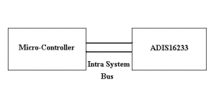

The different categories of intrasystem protocol mainly include the following.

* I2C Protocol
* SPI Protocol
* CAN Protocol

**Q. what is I2C Protocol ?**

**Ans** [I2C stands for the inter-integrated circuit](https://www.elprocus.com/i2c-bus-protocol-tutorial-interface-applications/) and it requires only two wires connecting all peripherals to the microcontroller. I2C requires two wires SDA (serial data line) and SCL (serial clock line) to carry information between devices. It is a master to a slave communication protocol. Each slave has a unique address. The master device sends the address of the target slave device and reads/writes the flag. The address matches any slave device that the device is ON, the remaining slave devices are disabled mode.

Once the address is match communication proceed between the master and that slave device and transmitting and receiving the data. The transmitter sends 8-bit data, the receiver replies 1-bit of acknowledgment. When the communication is completed master issues the stop condition. The I2C bus was developed by Philips Semiconductors. Its original purpose is to provide an easy way to connect CPU to peripherals chips.

Peripheral devices in embedded systems are often connected to the microcontroller as memory-mapped devices. I2C requires only two wires for connecting all the peripherals to the microcontroller. These active wires, called SDA and SCL, are both bidirectional. SDA line is a serial data line and the SCA line is a serial clock line.

**Q. Why given the pull-up resistors in I2C SCL and SDA line?**

* Both SDA and SCL lines are open-drain drivers.
* It can drive output low canot driver it high.
* For the lines to be able to go high you must provide pull-up resistors

**Q. what is SPI Protocol**

**Ans** SPI stands for the serial peripheral interface. It is one of the serial communication protocol developed by Motorola. Sometimes SPI protocol is also called a 4-wire protocol. It requires four wires MOSI, MISO, SS, and SCLK.SPI protocol used to communicate the master and slave devices. The master first configures the clock using a frequency.

The master then selects the particular slave device for communication by pulling the chip select button. That particular device is selected and starts the communication between the master and that particular slave. The master selects only one slave at a time. It is a full-duplex communication protocol. Not limited to 8-bit words in the case of bit transferring.

**Q. what is CAN Protocol ?**

**Ans** CAN stands for the controller area network. It is a serial communication protocol. It requires two wires CAN High (H+) and CAN low (H-).  It was developed by the Robert bosh company in 1985 for in-vehicle networks. It is based on a message-oriented transmission protocol.

**Q. what is Differences Between the Intra System Protocols ?**

**Ans** The intra system protocols mainly include I2C, SPI, and CAN

|  |  |  |
| --- | --- | --- |
| I2C | SPI | CAN |
| * I2C is an inter-integrated circuit | * SPI stands for serial peripheral interface | * The CAN stands for controller area network |
| * It is implemented by Philips | * SPI is developed by Motorola | * CAN is developed by Bosch |
| * I2C is a half-duplex protocol | * SPI is a full-duplex protocol | * CAN is a full-duplex protocol |
| * Synchronization | * Synchronization | * Synchronization |
| * It is a two-wire protocol like SCL & SDL | * It is a four-wire protocol like SCL, MISO, MOSI & SS | * It is a two-wire protocol like CANH+ and CAN H- |
| * It is a multi-master protocol | * It is a single master protocol | * It is a multi-master protocol |
| * It is used in the circuit board | * It is used in the circuit board | * It is used in two circuit board |

**Q. what is Communication Protocols in IoT ?**

The IoT based devices are more susceptible to threats. So these security loopholes can be reduced by using the correct protocols. Communication protocols in IoT are types of communication that ensure the finest security toward the data being exchanged among the IoT connected devices.

The connection of these devices can be done through an IP network otherwise a non IP network but, there is a disparity within their power, range & memory used. The connection throughout IP networks is difficult & takes huge memory as well as power from these devices as the range is not a trouble. Alternatively, [Bluetooth](https://www.elprocus.com/bluetooth-protocol-types-and-data-exchange/) which is known as non-IP networks needs low power and memory however they have a limitation in the range.

The main benefits of [IoT communication protocols](https://www.elprocus.com/iot-protocols-and-its-architectures/) are high quality, credibility, interoperability, innovation flexibility & global scalability. IoT protocols are available in two types mainly IoT network protocols and IoT data protocols.

The list of Top 10 IoT Communication Protocols includes the following.

* WiFi
* SigFox
* Bluetooth
* LoRaWAN
* NFC (Near Field Communication)
* Z wave
* Zigbee
* OPC- UA
* Cellular
* MQTT

**Q. what is Data Communication Protocols**

**Ans** Data communication protocols are very significant for communication because they are used for understanding the networks or computers or devices to each other.

These types of protocols use typical rules as well as methods like a common language to interact with computers or networks to each other. For instance, if a user wants to send an e-mail to another, then the user will create the e-mail on his personal computer by including the details along with the message and attachments.  
Once the user sends the e-mail, then immediately multiple actions can take place so that the receiver gets the email. The message moves over the network and reaches the recipient. These protocols provide the information on how the note will be enclosed so that it can move over the system, how the receiver computer can verify for errors, etc

**Q. what is PLC Communication Protocols ?**

**Ans** The following primary communication protocols are used for the PLC as well as other connections of the network which supports through different PLC software products. These protocols mainly depend on the basic three parts like baud rate, length of network & the number of nodes. The list of PLC communication protocols includes the following.

* Profibus
* Interbus
* ControlNet
* ProfiNet
* CompoNet
* DirectNet
* Modbus
* MelsecNet
* EtherCAT
* DF-1 Protocol
* Optomux
* Host Link Protocol
* RAPIENet
* therNet/IP
* Mechatrolink
* PPI- Point to Point
* Ethernet Powerlink
* Multi-Point Interface (MPI)
* Data Highway (DH)
* Actuator Sensor Interface (ASI)
* DeviceNet
* Highway Addressable Remote Transducer Protocol (HART)
* Ethernet Global Data (EGD)
* Factory Interface Network Service Protocol (FINS)
* Open Smart Grid Protocol (OSGP)
* Recommended Standard (RS-232, RS- 422, and RS-485) Protocols
* Bristol Standard Asynchronous Protocol (BSAP)
* Distributed [Network Protocol](https://www.elprocus.com/internet-protocol-suite-and-its-architecture/) (DNP3)
* Service Request Transport Protocol (SRTP)
* Smart Distributed System Protocol (SDS)
* Process Image Exchange Protocol (PIEP)

**Q. what is Characteristics of PLC Communication Protocols**

**Ans** The standard protocols are used once PLC modules are connected over the network. The different types these protocols mainly supports different speed, distance & the number of connecting devices.

* Ethernet protocol baud rate is 100 Mb/s, length is Few Km and 255 nodes.
* RS-485 baud rate is 10 Kb/s, the length is 1.2 Km, and 32 nodes
* Profibus protocol baud rate is 5-12 Mb/s, the length is 15 Km and 127 nodes.
* RS-232 baud rate is 19.2 Kb/s, the length is 10m and 1 node
* MPI protocol baud rate is 19.2- 38.4 Kb/s, the length is 50 m and 32 nodes.
* PC Adapter baud rate is 9600 Kb/s, length is 15 m, and 1 node
* PPI protocol baud rate is 187.5 Kb/s, the length is 500 m, and 1 node.
* USB Adapter baud rate is 57.6 Kb/s, the length is 10 m and 1sec
* DH protocol baud rate is 230.4 Kb/s, the length is 3.048 Km, and 64 nodes
* Device Net protocol braud rate is 500 Kb/s, the length is 0.487, and 64 nodes
* Control Net protocol baud rate is5 Mb/s, the length is 30 Km

**Q. what is Communication Protocols in Cloud Computing**

**Ans** The cloud supports two communication protocols for communication as well as connection like MQTT and HTTP. The communication of these devices can be done through Cloud IoT Core across a bridge either the HTTP or the MQTT. These bridges are central components in Cloud IoT Core. Once you create a registry of a device, then you can choose protocols to allow HTTP, MQTT, etc. The standard protocol like MQTT is used frequently and it is supported through embedded devices. This protocol is common in the interactions of the machine to machine.

HTTP is a connectionless protocol, so devices do not maintain a connection to the cloud IoT core. As an alternative, they send requests as well as get responses. The protocols of cloud computing are a set of rules that permit two electronic elements to unite as well as exchange the data with each other. It is mainly used for communication, storage, encryption, networks, decryption, security, management of user login, etc. Some cloud computing protocols include

* Gossip Protocol
* MTP (Media Transfer Protocol)
* CLNP (Connection Less Network Protocol)
* CEE (Coverage Enhanced Ethernet Protocol)
* SRP (State Routing Protocol)
* SSHP (Secure Shell Protocol)
* IGMP (Internet Group Management Protocol)

Q. what is computer memory ?

In computing, memory is a device or system that is used to store information for immediate use in a computer or related computer hardware and digital electronic devices. The term memory is often synonymous with the term primary storage or main memory.

Q. what is types of memory chart ?

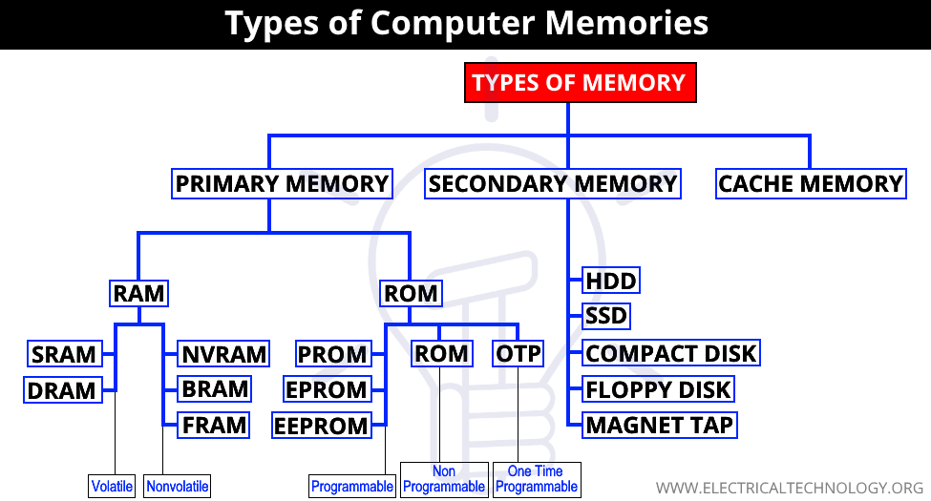

Q. what is resistance ?

A. **Resistance** is the property of material to oppose the flow of electric current passing through it. Specific **resistance** is defined as the **resistance** offered by a **unit** length and **unit** cross-section of the substance to a current when a voltage is applied to it. **Its** SI **unit** is Ω−m.

Q. what is resistor ?

A. A resistor is a passive two-terminal electrical component that implements electrical resistance as a circuit element. In electronic circuits, resistors are used to reduce current flow, adjust signal levels, to divide voltages, bias active elements, and terminate transmission lines, among other uses.

Q. what is difference between resistance and resistor ?

A. **Resistance** is the property of a conductor, which determines the quantity of current that passes through it when a potential **difference** is applied across it. A **resistor** is a electrical componet **with a** predetermined electrical **resistance**, like 1 ohm, 10 ohms 100 ohms 10000 ohms etc.

Q. what is reactance ?

A. n electric and electronic systems, reactance is the opposition of a circuit element to the flow of current due to that element's inductance or capacitance. Greater reactance leads to smaller currents for the same voltage applied.

Q. what is working of resistance ?

A. The working of a resistor can be explained with the similarity of water flowing through a pipe. Consider a pipe through which water is allowed to flow. If the diameter of the pipe is reduced, the water flow will be reduced. If the force of the water is increased by increasing the pressure, then the energy will be dissipated as heat. There will also be an enormous difference in pressure in the head and tail ends of the pipe. In this example, the force applied to the water is similar to the current flowing through the resistance. The pressure applied can be resembled to the voltage.

Q. what is types of resistor ?

A. There are two basic types of resistors.

* ***Linear Resistors***
* ***Non Linear Resistors***

#### **Linear Resistors:**

Those resistors, which values change with the applied [voltage](https://www.electricaltechnology.org/2020/07/what-is-voltage.html) and temperature, are called linear resistors. In other words, a resistor, which current value is directly proportional to the applied voltage is known as linear resistors.

Generally, there are two types of resistors which have linear properties.

* **Fixed Resistors**
* **Variable Resistors**

##### **Fixed Resistors**

As the name tells everything, fixed resistor is a resistor which has a specific value and we can’t change the value of fixed resistors.

Types of Fixed resistors.

* **Carbon Composition Resistors**
* **Wire Wound Resistors**
* **Thin Film Resistors**
* **Thick Film Resistors**

###### **Carbon Composition Resistors**

A typical fixed resistor is made from the mixture of granulated or powdered carbon or graphite, insulation filler, or a resin binder. The ratio of the insulation material determines the actual resistance of the resistor. The insulating powder (binder) made in the shape of rods and there are two metal caps on the both ends of the rod.

There are two conductor wires on the both ends of the resistor for easy connectivity in the circuit via soldering. A plastic coat covers the rods with different color codes (printed) which denote the resistance value. They are available in 1 ohm to 25 mega ohms and in power rating from ¼ watt to up to 5 Watts.

[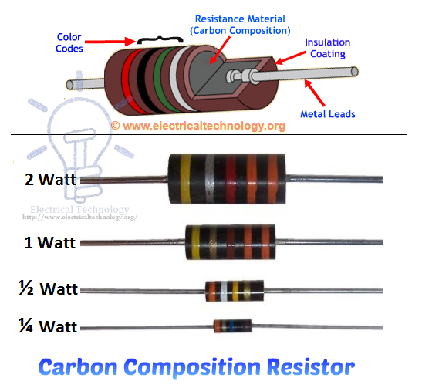](https://www.electricaltechnology.org/wp-content/uploads/2015/01/Carbon-Composition-Resistors.Construction-and-Wattage-Rationg.png)Construction and Wattage Rating of Carbon Composition Resistors.

**Characteristic of Fixed Resistors**

Generally, they are very cheap and small in size, hence, occupy less space. They are reliable and available in different ohmic and power ratings. Also, fixed resistor can be easily connected to the circuit and withstand for more voltage.

In other hand, they are less stable means their temperature coefficient is very high. Also, they make a slight noise as compared to other types of resistors.

###### **Wire wound Resistors**

Wire wound resistor is made from the insulating core or rod by wrapping around a resistive wire. The resistance wire is generally Tungsten, manganin, Nichrome or nickel or nickel chromium alloy and the insulating core is made of porcelain, Bakelite, press bond paper or ceramic clay material.

The manganin wire wound resistors are very costly and used with the sensitive test equipments e.g. Wheatstone bridge, etc. They are available in the range of 2 watts up to 100 watt power rating or more. The ohmic value of these types of resistors is 1 ohm up to 200k ohms or more and can be operated safely up to 350°C.

in addition, the power rating of a high power wire wound resistor is 500 Watts and the available resistance value of these resistors are is 0.1 ohm – 100k Ohms.

[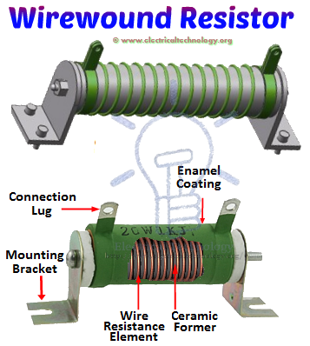](https://www.electricaltechnology.org/wp-content/uploads/2015/01/Wire-wound-Resistors-Types-and-Construction.png)

Construction of Wire wound Resistors

**Advantages and Disadvantage of Wire wound Resistors**

Wire wound resistors make lower noise than carbon composition resistors. Their performance is well in overload conditions. They are reliable and flexible and can be used with DC and Audio frequency range. Disadvantage of wire wound resistor is that they are costly and can’t be used in high frequency equipments.

**Application of Wire Wound Resistors**

Wire wound resistors used where high sensitivity, accurate measurement and balanced current control is required, e.g. as a shunt with ampere meter. Moreover, Wire wound resistors are generally used in high power rating devices and equipments, Testing and measuring devices, industries, and control equipments.

###### **Thin Film Resistors**

Basically, all thin film resistors are made of from high grid ceramic rod and a resistive material. A very thin conducting material layer overlaid on insulating rod, plate or tube which is made from high quality ceramic material or glass. There are two further types of thin film resistors.

* **Carbon Film Resistors**
* **Metal Film Resistors**

###### **Carbon Film Resistors**

Carbon Film resistors contains on an insulating material rod or core made of high grade ceramic material which is called the substrate. A very thin resistive carbon layer or film overlaid around the rod. These kinds of resistors are widely used in electronic circuits because of negligible noise and wide operating range and the stability as compared to solid carbon resistors.

Construction of Carbon Film Resistors & Its labels.

###### **Metal Film Resistors**

Metal film resistors are same in construction like Carbon film resistors, but the main difference is that there is metal (or a mixture of the metal oxides, Nickel Chromium or mixture of metals and glass which is called metal glaze which is used as resistive film) instead of carbon. Metal film resistors are very tiny, cheap and reliable in operation. Their temperature coefficient is very low (±2 ppm/°C) and used where stability and low noise level is important.

* Related Post: [Types of Solar Panel and Which one is the best PV Panel](https://www.electricaltechnology.org/2014/10/pv-types-of-solar-panel-best-pv-panel.html)

Construction and internal parts of Metal Film Resistor. .

###### **Thick Film Resistors**

The production method of Thick film resistors is same like thin film resistors, but the difference is that there is a thick film instead of a thin film or layer of resistive material around. That’s why it is called Thick film resistors. There are two additional types of thick film resistors.

* **Metal Oxide Resistors**
* **Cermet Film Resistors**
* **Fusible Resistors**

###### **Metal Oxide Resistors**

By oxidizing a thick film of Tin Chloride on a heated glass rod (substrate) is the simple method to make a Metal oxide Resistor. These resistors are available in a wide range of resistance with high temperature stability. In addition, the level of operating noise is very low and can be used at high voltages.

* Related Post: [Types of Diodes and Their Applications – 24 Types of Diodes](https://www.electricaltechnology.org/2018/12/types-of-diodes-their-applications.html)

###### **Cermet Oxide Resistors (Network Resistors)**

In the cermet oxide resistors, the internal area contains on ceramic insulation materials. And then a carbon or metal alloy film or layer wrapped around the resistor and then fix it in a ceramic metal (which is known as Cermet). They are made in the square or rectangular shape and leads and pins are under the resistors for easy installation in printed circuit boards. They provide a stable operation in high temperature because their values do not change with change in temperature.